## ESSENTIAL HEALTH PARAMETERS

# BMI (Body mass index)

* Normal (18.5 – 24.9): Healthy
* Abnormal Values
* Under weight (<18.5): Diseases => Fertility issues, Muscle wasting

Precautions => Diet, strength training

* Over weight (25-29.9): Diseases => Respiratory issues, hormonal issues

Precautions => Sleep, hydration

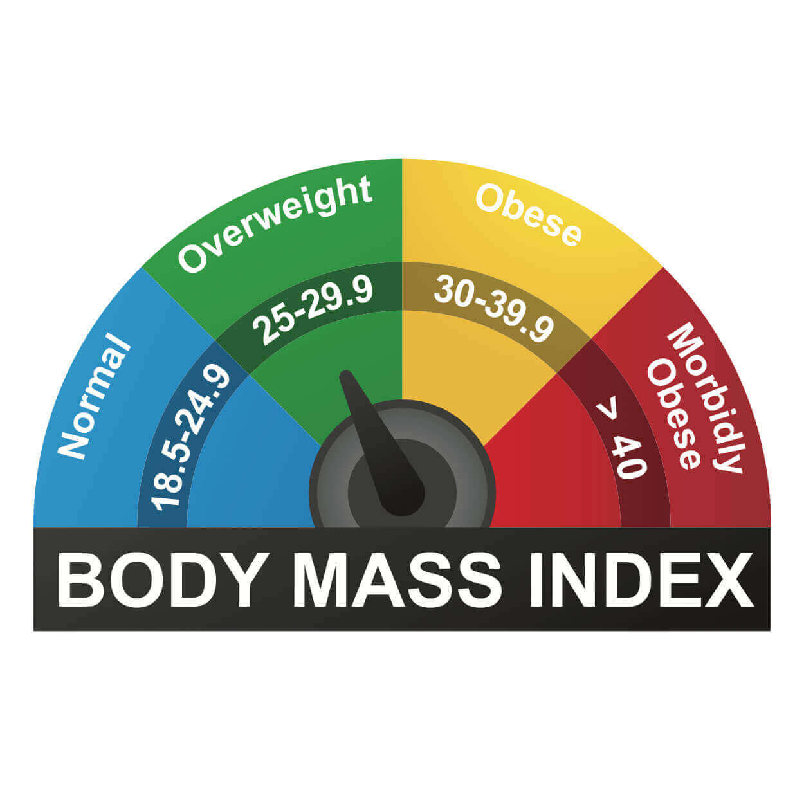

# 2.SPO2 (OXYGEN SATURATION)

* Normal (95% to 100%): Healthy
* Abnormal (below 95%): Diseases => Asthma, pulmonary fibrosis

Precautions => Stay clam, check positioning

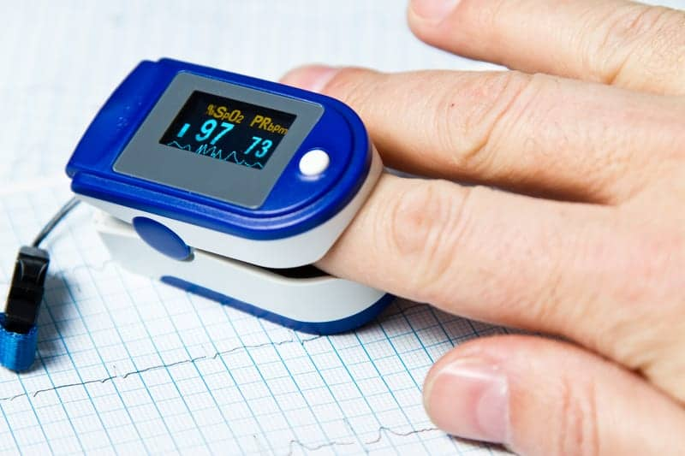

# 

# 3.HEART RATE

* Normal Range: 60 to 100 beats per minute
* Abnormal: Below 60 (Bradycardia): Diseases=> heart conditions, medication side effects

Precautions=>Exercise, diet

Above 100(Tachycardia): Diseases=> Heart failure, dehydration

Precautions=> sleep, medical evaluation



# 4. BP (BLOOD PRESSURE)

* Normal range
* Systolic:90 to 120mmHg
* Diastolic:60 to 80mmHg
* Abnormal values
* High BP

Stage 1: Systolic 130-139mmHg: Diseases=> Heart diseases, Kidney diseases

Diastolic 80-89mmHg Precautions=> Limit alcohol, Reduce stress

Stage 2: Systolic >= 140mmHg

Diastolic >= 90mmHg

* Low BP

Systolic below 90mmHg: Diseases=> Heart problems, dehydration

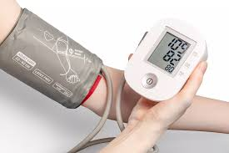 Diastolic below 60mmHg Precautions=> Salt intake, hydration

# 5.BODY TEMPERATURE

* Normal Range : App 36.5c – 37.5c
* Abnormal values
* Fever : (Above 38c or 100.4F) Diseases=>fever , hypothermia
* 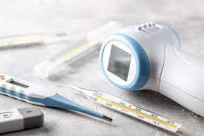Hypothermia: (Below 35c or 95F) precautions=>stay hydrated , rest